**Now please answer the following questions:**

1. Which pins on the Nucleo F303RE can be used to read analog values?
   1. A0 to A5
2. As soon as the ‘adc’ pins is read, what is the minimum and maximum voltage that will be measured?
3. How many bits does the ADC of the Nucleo F303RE have? Check the datasheet!
   1. 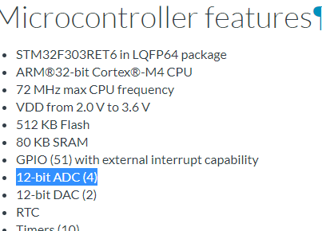  
        
      12-Bit!